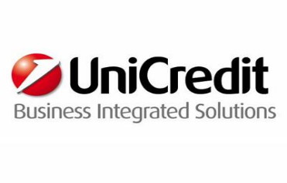

Group Risk Management - Junior Java Software Development Engineer – 2102
Vacancy Type: Graduate
Job Area: Information Technology
Location: Milano
Area description
UniCredit Business Integrated Solutions (UBIS) is an ICT company that operates on a global level as the main ICT service provider for UniCredit. With 19 locations in 8 European companies, UBIS is the provider for all technological and organisational solutions.
Function description
“Product Line Group Risk Management” (GRM) ensures the implementation and evolution of the ICT solutions architecture, for the Risk Management Competence Line, fulfilling both regulatory and managerial business requirements.
Is therefore responsible for designing, implementing and maintaining ICT solutions for the centralized calculation and the monitoring of key indicators for all risk categories (i.e. Credit Risk, Market Risk, Counterparty Credit Risk, Operational Risk, Pillar II risks, etc.), coherently with local and international regulations (e.g. Basel III). In particular it ensures the maintenance and development of models/systems for:
- Group-wide and local Credit Risk models calculation (RWA, Economic Capital, Stress testing) and managerial Credit Risk reporting, leveraging ARAMIS as target Credit Risk management solution;
- Group-wide Market Risk and Counterparty Credit Risk models and reporting processes;
- PD/Rating calculation;
- Credit Risk models estimation, validation and back-testing (Laboratory Environment);
- Support to Pillar II risks calculation for ICCAP reporting (e.g.: Business Risk, Financial Investment Risk, Real Estate Risk, risk integration);
- Reporting to local regulators for all risk types.
Job description
Key duties and responsibilities of the role include:
- Implement, test and maintain complex High Performace Computing projects with a focus on collecting, parsing, analyzing and process large sets of data on a grid computing platform
- Implement high-performance scalable applications in Java
- Perform profiling, troubleshooting of existing solutions
- Develop enterprise level applications to manage data as a service
- Implement and use continuous integration solutions
- Create technical documentation.
What we expect from you
- Collaboration and team work aptitude
- Efficiently communicate verbally and writing
- Fluent English (written and spoken)
- Problem solving
Desired skills required:
- Master's Degree in Software Engineering, Computer Science or similar
- Experience with Java object-oriented programming. Knowledge of C/C++ and CUDA SDK is a plus
- Good knowledge on Java SE. Knowledge of Java EE software solutions is a plus.
What we offer to you
If you are looking for an international career in the Technology sector, UniCredit Business Integrated Solutions is the right place for you! You will be challenged with an unique experienced to foster your charisma and creativity, technical competences but also team spirit and continuous learning attitude.
Contract Type: Permanent Contract
Career website: www.careers.unicreditgroup.eu
Tutti gli interessati alla posizione dovranno candidarsi, accedendo al Sito di UniCredit tramite il seguente link : https://career012.successfactors.eu/career?company=Unicredit., fino al 02/08/2016.

