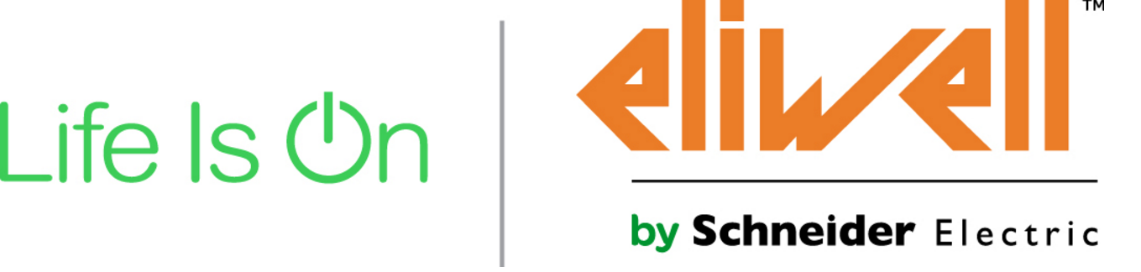

Global Solution Architect (GSA) for Solution Center HVAC
As a Global Solution Architect m/f you will be responsible for adapting, promoting and supporting integrated, intelligent HVAC solutions for customers in the HVAC market and to implement the Schneider Electric strategy with Global Strategic Accounts.
Must possess the ability to build solutions by understanding the customer context, including all stakeholders, process and needs, as well as technical complexity induced by the integration of numerous interconnected components and sub-systems.
Strong relationship with L3 team for HVAC.
Your tasks – versatile:
- Understand customer applications for HVAC and life cycle expected performances.
- Bring differentiation and innovation to support the sales in front of assigned Strategic Accounts and potential customers, addressing business needs, customer process constraints, and technical challenges.
- Demonstrate the value of Schneider proposition to deliver profitable solutions to targeted market segments.
- Prescribe SE offers and influence tender specifications.
- Prepare and negotiate with the customer the operational description of the solution, as well as the functional description including quantified performance levels and related budgets.
- Adapt reference architectures prepared for HVAC market to elaborate a solution in line with customer expectations, while re-using to save time, optimize costs and reduce risks.
- Anticipate complementary functions selling opportunities for some add-ons in a later stage of the project.
- Network with other architects to capitalize experience for his/her segment.
- Solution Marketing:
  - Promote the unique Customer Value Propositions for the Segment to influence customers/consultants with SE Solutions by prescribing differentiating architectures very early in the customer project lifecycle
  - Improve those architectures with use cases from his/her own customers
- Solution Selling:
  - Key mission is to adapt reference architectures to meet specific GSA customer needs.
  - Perform gap analysis between customer needs and reference architectures and adapt the proposed architecture and project scope to satisfy key decision criteria for the customer (functions, performance & budget)
  - Work with end users and consultants to influence the specifications and prescribe SE offers with differentiating features and benefits.
  - Contribute to Solution selling, in close cooperation with the KAM for global accounts located in his/her country, as well as the SAE and ensure consistency of deployments globally.
- Support to the Countries:
  - Provides all relevant information and system analysis results as well as contractual agreements to the Countries.
  - Train, certify, and support Countries.
- Networking
  - Share experience with other global and local Solution architects.

- Develop solutions/applications for internal and external customers
- Work on POC
- Support launches
- Support R&D for validation, AFB and TVDA
- Animate ADE, L2G, knowledge program
Your profile – qualified:
- Engineering Degree aligned with industry – Mechanical, Electrical, Electronics & software
- Customer understanding: 3-5 years of experience in the targeted segment leading to good knowledge of customer vocabulary, pain-points, expectations and deliverables
- System architecture methodology, starting from customer needs identification
- Ability to influence and convince
- Communication skills ( internal & external)
- Ability to foster cooperation
- Willling to travel about 50%

Place of work
Pieve D’alpago (Belluno)

deadline: 30 novembre 2017
mail to: michela.merlin@schneider-electric.com

