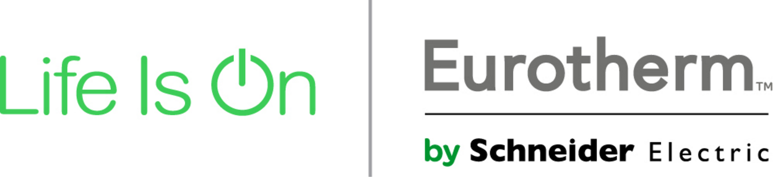

Eurotherm is a leading provider of control systems, automation, software solutions, products for our markets, services and consulting to global manufacturing and infrastructure industries. The marketplace knows us for our wide portfolio and our capability to meet customer requirement. Our solutions include control and measurement instrumentation, safety, critical and distributed control systems. A wide range of real-time operations management software and professional services.

We are currently looking for a Service Engineer for our System Service team. He will be base in Puglia Region site and available for business trips
Eurotherm works in a dynamic market, so we are looking for a dynamic person who can face the technological challenges of the future

Roles and Responsibilities:

▪ Troubleshoot hardware, software and systems failures and determine the most cost effective repair to minimize customers downtime;
▪ Perform preventive and remedial maintenance on instruments and systems;
▪ Provide trainings and instruct customers in the operation and maintenance of the system;
▪ Provide support to system sales team and assistance in proposal preparation during the pre-sales phase;
▪ Provide long and short commissioning onsite
▪ Available for on-call rotation as required
▪ Works in a structured team

Qualifications:

▪   Bachelor Degree in IT, Electronics or Industrial Automation
▪ 1 to 2 years of related experience in control automation in oil&gaz, chemical, life-science, glass or water industry;
▪ PLC/DCS programming experience;
▪ Prior experience in maintenance of field instruments/equipments is an advantage;
▪ Italian mother language and fluent English;
▪ Very good communication skills, customer focus, ability to work independently but also in a team;
▪ Knowledge in IRP;
▪ Driving license;
▪ The role requires work on-site up to 90% of working time and flexibility for travelling within Italy and abroad.

We offer an open ended contract (full time) and a competitive salary package;
Eurotherm by Schneider Electric is a great place to work by giving you the opportunity to grow and be recognized for your achievements.
If you are interested in making the next step with us, please send your application (CV) to Ms. Michela Merlin by email: michela.merlin@schneider-electric.com ) entro il 30 novembre 2017

