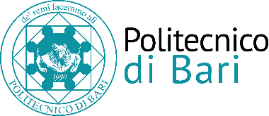

Summer School Self Made Architecture "SMA03"

ATTACHEMENT 1: ENROLLMENT APPLICATION*

To the Rector of Politecnico di Bari
Directorate of Resource Management and Institutional Services Management
Sector of Research and International relation
Via Amendola 126/B
70126 Bari

I the undersigned Surname _____________ First name_______________________________
born in ________________________ on _______________________________________
Nationality_____________________________
Residence address (number, street, Zip code, town, Country)
______________________________________________________________________________
Telephone number: ______________________________________________________________
E-mail : _________________________________________________________________________

HEREBY APPLY FOR THE ENROLLMENT

IN SUMMER SCHOOL SELF MADE ARCHITECTURE 03 "SMA03" – A.A. 2017/2018

I the undersigned enclose the following documents with this application:
- copy of the ID card, passport, driving license, to be signed.

Date and place, Signature______________________________

* This Enrollment application must be sent by e-mail no later than 3 days from the publication of the decree of final approval of deeds in the online register of the Politecnico di Bari. Otherwise, the candidate will be not admitted.

