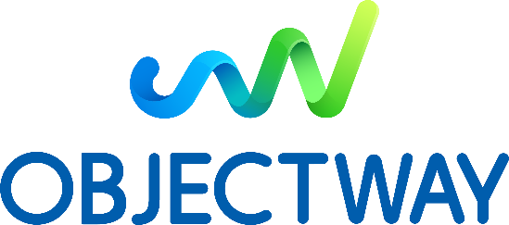

Devops Trainee (internship)
MILANO
Objectway is a Top 100 global FinTech provider and a leader in the Wealth, Investment & Asset Management Software Industry, with more than 700 employees and offices in Italy, UK, Ireland, Benelux, South Africa.
ACTIVITIES
You will do your internship within DevOps team involved in designing, automatically deploying and maintaining our product solution for Fintech world. You will work in a fully integrated way with our product development teams by providing relevant tools and by supporting architectural decisions based on a DevOps mindset.
During this internship, the activities you may undertake include:
- Container architecture (Docker) and container orchestrators (Rancher, Kubernetes)
- Different scripting/programming languages (bash, batch, Groovy, Golang, Python)
- Linux/Unix platform and Windows platform regarding administration, infrastructural setup, scripting and virtualization
- Cloud Platform (Google Cloud, AWS) and related tasks
- Code versioning systems (Git, Mercurial) and CI/CD frameworks (Jenkins)
- Design and developing highly available and scalable distributed architectures based on microservices
REQUIRED SKILLS
- Hold a Bachelor's degree in Computer Science, Computer Engineering or related subjects
- Strong interest in developing computer programming as a competency
- Knowledge of Object-Oriented development.
- Be a fast learner, able to handle stress and be a team player
- Attitude in problem solving and troubleshooting
WE OFFER
- A six-months internship that enables you to put your theoretical knowledge into practice to gain on-the-job experience
- At the end of the program will be offered a full-time employment contract
- This role provides you a unique opportunity to develop your career
- Paid internship: 1000€ per month
Approximate start date: December
If you’re interested in our offer, you can apply here: https://careers.objectway.it/job?id=70
Due date: December 31st , 2019

